

T1100**(E)**(M29)T

**NATIONAL CERTIFICATE**

# MECHANOTECHNICS N4

(8190194)

**29 March 2018 (X-Paper)**

**09:00–12:00**

**This question paper consists of 6 pages and 3 formula sheets.**

**DEPARTMENT OF HIGHER EDUCATION AND TRAINING**

**REPUBLIC OF SOUTH AFRICA**

NATIONAL CERTIFICATE

MECHANOTECHNICS N4

TIME: 3 HOURS

MARKS: 100

## INSTRUCTIONS AND INFORMATION

1. Answer ALL the questions.

1. Read ALL the questions carefully.

1. Number the answers according to the numbering system used in this question paper.

1. Sketches must be large, neat and fully labelled.

1. Write neatly and legibly.

## QUESTION 1

1.1 Name and describe FIVE ways in which ball and roller bearings can be damaged. (5 × 2) (10)

1.2 Corrosion can be defined as the destruction of a material as a result of chemical, electrochemical or metallurgic interaction between the material and the environment. The different forms corrosion can take on are based on the appearance of the corrosion metal.

Name and briefly describe FIVE forms of corrosion. (5 × 2) (10)

1.3 There are certain factors that should be considered during the planning and design of a good factory layout.

Name TEN of these important factors. (10)

**[30]**

## QUESTION 2

The following information applies to a V-belt drive transmitting 35 kW:

Effective diameter of motor pulley = 35 mm

Speed of the motor pulley = 825 r/min

The V-groove angle of the pulley = 40°

Coefficient of friction = 0,3

Contact angle of the belt = 188°

Mass of the belt = 0,98 kg per metre length

Maximum allowable tension per belt = 740 N

Efficiency = 79%

Determine:

2.1 The belt speed (2)

2.2 The centrifugal tension (2)

2.3 The input power (2)

2.4 The tension in the tight and slack sides of the belt (6)

2.5 The number of V-belts (2)

**[14]**

## QUESTION 3

FIGURE 1 shows the setup of a cutting tool held in the tool holder of a shaping machine. The ram of the shaping machine has a mass of 100 kg and is in operation with a cutting stroke length of 250 mm.

The total work done during one cutting stroke is equal to 125 J and the coefficient of friction between the ram and the slides is 0,2.

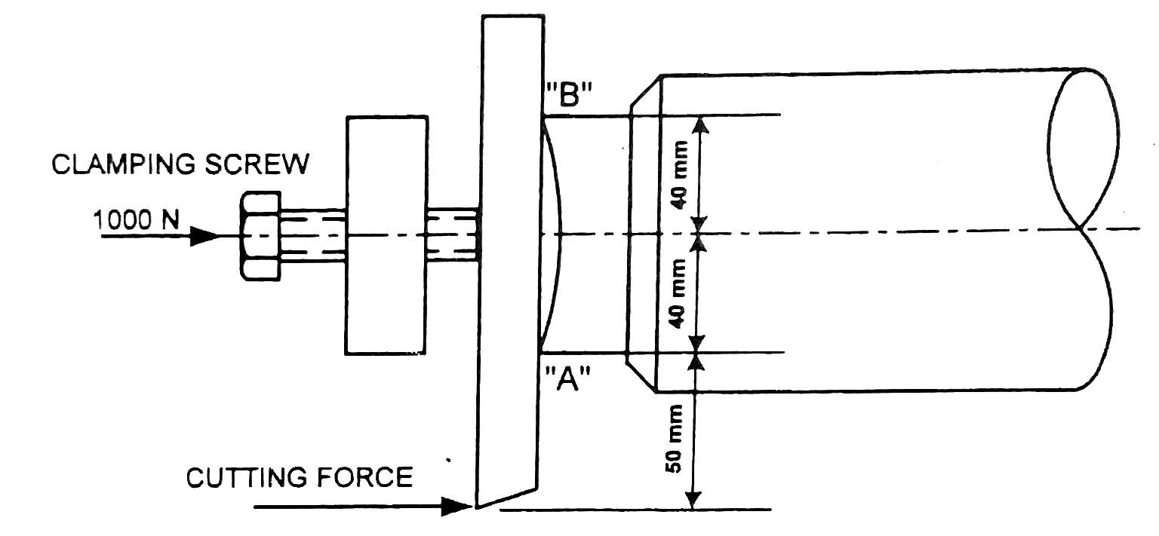

B

A

## FIGURE 1

Calculate:

3.1 The work done to overcome the friction between the ram and the slides (3)

3.2 The cutting force exerted on the cutting tool (3)

3.3 The forces exerted on the two contact points A and B, if the clamping force in

the clamping screw is 1 000 N (8)

**[14]**

## QUESTION 4

|  |  |
| --- | --- |
|  |  |
| **FIGURE 2** |  |
| 4.1 Explain step-by-step, how the precision balls are used to determine the included angle of the ring gauge. | (3) |
| 4.2 Make a large, clear drawing of the diagram and show the included angle. | (3) |
| 4.3 Use the dimensions as given on the diagram and calculate the angle of the ring gauge. | (8) |
| **QUESTION 5** | **[14]** |
| The following specifications apply to a simple gear train with a pinion A and a gear wheel B.    Module = 10 mm  Pressure angle = 20°  Gear ratio = 3 : 2  PCD of pinion = 160 mm    Calculate: |  |
| 5.1 The number of teeth on each gear wheel | (4) |
| 5.2 The addendum and dedendum of the gear teeth | (2) |

FIGURE 2 shows a tapered ring gauge which is checked for accuracy by means of two precision balls.

5.3 The outside diameters of both gears (2)

5.4 The pitch-circle diameter of the gear wheel (1)

5.5 The total depth of the teeth (1)

5.6 The tooth thickness at the pitch circle (4)

**[14]**

## QUESTION 6

A sharp-edge orifice, 52 mm in diameter, in the side of a large tank is discharging water under a constant pressure head of 4,5 m. The diameter of the vena contracta is 41 mm. The horizontal distance of the water jet is 2,15 m and the jet falls 327 mm vertically.

Determine:

6.1 The theoretical flow velocity of the water

6.2 The actual flow velocity of the water

6.3 The theoretical delivery of the water

6.4 The actual delivery of the water

6.5 The coefficient of delivery (cd)

6.6 The coefficient of velocity (cv)

6.7 The coefficient of contraction (cc)

(7 × 2) **[14]**

**TOTAL:**  **100**

## MECHANOTECHNICS N4

**FORMULA SHEET**

*PCD*

*1. m*  *T 2. DO = m × (T + 2)*

*m*

*3. C*  2 *(TA*  *TB) 4. Ke*  1 2

# *mv* 2

*TA*

*5. VR*   *PCD of gear*

*TB 6. VR*  *PCD of pinion*

*NB*

*7. VR*  *NA8. NA × TA = NB × TB*

2 *T*

*9. Ft* 

*PCD 10. Fr = Ft × Tan*

1. *Fn = Ft × Sec*

1. *Ie = IA + (VR)2 IB + (VR)2 IC + (VR)2 ID*

|  |  |
| --- | --- |
| *13. T* *= Ie ×* *A*    *NB*  *15.* *B* *B*  *IA*  *NA* *A* *A IB*    *17. P*  *PCD n*    *19. TA = TS + 2TP*      *21. v =*  *× (d + t) × N*    *T*1  *23.*  *e* *T*2    *25. Tc = m × v2* | *( NB ) TBC ( ND) TD*  *14. T* *TA*    *( NA)* 1 *( NA)* 12    *16. TOUTPUT*  *TINPUT*  *GR* *η*      *18. Ti + To + Th = 0*    *Input speed Teeth on driven gears*  *20.*   *Output speed Teeth on driving gears*    *22. P = Te × v*      *24. T1 =*  *× A*    *26.*  *TC*  *e**cosec* *T*1  *T*2 *TC* |

*D*  *d*2

1. *L* *D*  *d*  2*C*

2 4 *C*

1. *Tg = m × g × sin* *29. v = T × r*

Please turn over

*30. v*   *g**r*

*32. v*  *gr*1*TanTan*

*n*

*T*1 1*Tan*

*34. T*2 1*Tan*

*36. Cos*  *R*  *r*

2 *C*

*38. T1 = w × n × ft*

*I* 

*40. t* 

*T*

*42. T = F × r*

*44. do = de + 0,65P*

1. *h*  *m*14 *sin**Cos*

*p*1 *(v*1*)*2 *p*2 *(v*2*)*2

1.   *gh*1   *gh*2

*Rho* 2 *Rho* 2

*gx*2

1. *Vw (Va )* 

2*y*

|  |  |
| --- | --- |
|  |  |
| *50. hf*  | 4 *f* *v*2    2 *g* *d* |

*Cd*  *A* *a*  *(*2*gh)*

*52. Q* 

*( A*2  *a*2 *)*

*54. V*  *(g*  *R**Cos**)*

*56. L = 2C +* *D*

*m*2 *g*  *S*

*58. One load =*

4 *h*

*31*

*.*

*h*

*r*

*b*

*g*

*v*









2

*33*

*.*













−





❑

❑

*tan*

*/*

*b*

*h*

*/*

*b*

*hTan*

*gr*

*v*

2

2

*35. Cos*  *R*  *r*

2 *C*

*37. m = w × t × L × ρ*

*39. P = Pg + Pµ*

*41. P*  2  *N* *T*

*60*

*43. w = do + 3d - 1,5155P*

*45. w**m (cos*2*)*

2

*49. v*  *C mi*

*f* *O*2

*51. hf* 

*3,026*  *d*5

*(*2*gh)*

*53. Q*  *Cd*  *A*

*(m*2 1*)*

*m* *s*

*55. Vol. bucket =*

 *v*

*m*1 *g*  *S*2

*57. Self-weight =*

8 *h*

1. *T (acc load) = (T1 - T2)R*

Please turn over

1. *T (acc drum) = I*  *mk*2 *a R*

1. *P = ω× T*

*63. Ke*  *I* 2

*65. P = Ke × operations/sec*

*67. µ = Tan* 

*69. T = µ × F × Re × n*

*71. T = µ × n × (Fc - S)R*

mv2

*73.* Fc



*62. ω = 2* *× N*

*work done*

*64. Ke*   *efficiency*

*66. (I1 + I2)ω3 = I1ω1 + I2ω2*

*Tan*

*68.* 

*Tan (**)*

*70. T*  *F*  *Re sin*

*72. Fc = m × ω 2 ×* 

1. *Tractive effort = mass on driving wheels × µ × g*

1. *Side thrust = FcCos* *mg Sin*

1.  *FcCos* *mgSin* *mgCos* *FcSin*

1. *Pl*  *CmgL*  *mgh*